Test Project

Startech's Days 2022

Day 1: Speed Modules

Skill : Web Development

Proof made by : Pierre Charlier

Employer : Forem - Cepegra

# Speed Modules

## Description of the project and the tasks to be carried out

Realization of mini-tasks divided into 3 areas: HTML/CSS, JS, PHP.

Duration: 1 h 30 and 30 minutes.

## HTML & CSS

### A1 Tabs

Reproduce the screenshot provided using only HTML and CSS.

### A2 Toggle (Normal)

To create an IOS Toggle switch using HTML and CSS only. View video for animation details.

|  |  |
| --- | --- |
|  |  |

### A3 Important

Without changing the HTML code, apply a red background to all <div> with a

attribute "data-important".

### A4 Animation

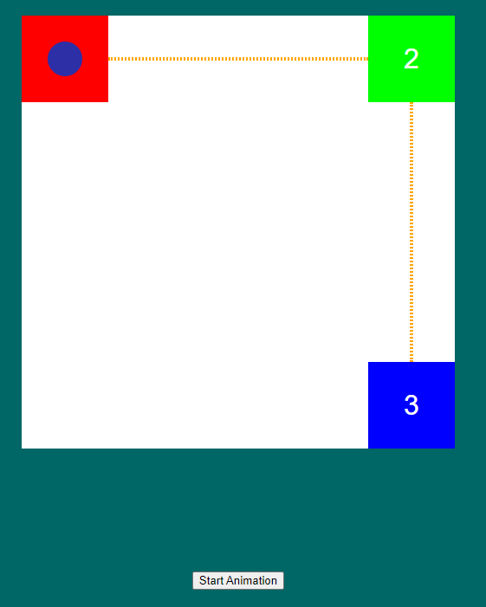

Without touching the HTML code or the JavaScript, add a transition allowing the circle to go from square 1 to square 3, when the button is clicked. The circle should follow the dotted line and pass through square 2. The total animation should last 2 seconds and follow a linear timing function.

## JavaScript

### B1 The number game

The user enters a number between 1 and 100 in an input. When he clicks on a button

If you select "validate", an integer is drawn between 1 and 100 and displayed in a #result div. If the

If the margin of error is less than or equal to 10, an alert message will indicate "Bravo". Otherwise, this

message says "Lost :("

Examples:

- Number entered in the input: 10, number drawn: 50 => Lost :(

- Number entered in the input: 40, number drawn: 50 => Bravo

- Number entered in the input: 60, number drawn: 50 => Bravo

- Number entered in the input: 61, number drawn: 50 => Lost :(

- Number entered in the input: 50, number drawn: 50 => Bravo

### B2 The word game

When a "Start" button is clicked, a word of 5 characters taken at random from the list provided in JS is displayed in an avlec element of the "textToCopy" class. The user must copy it as quickly as possible into the text field.

As soon as the two words are identical, a message (*alert*) should appear with the number of seconds that have elapsed since the click on Start (round this number up).

### B3 Simple Image Filter (Difficult)

You must create a function that allows you to add a filter in a certain image using canvas. This speed Project is divided into two parts.

**Part 1**

● Develop the following design:

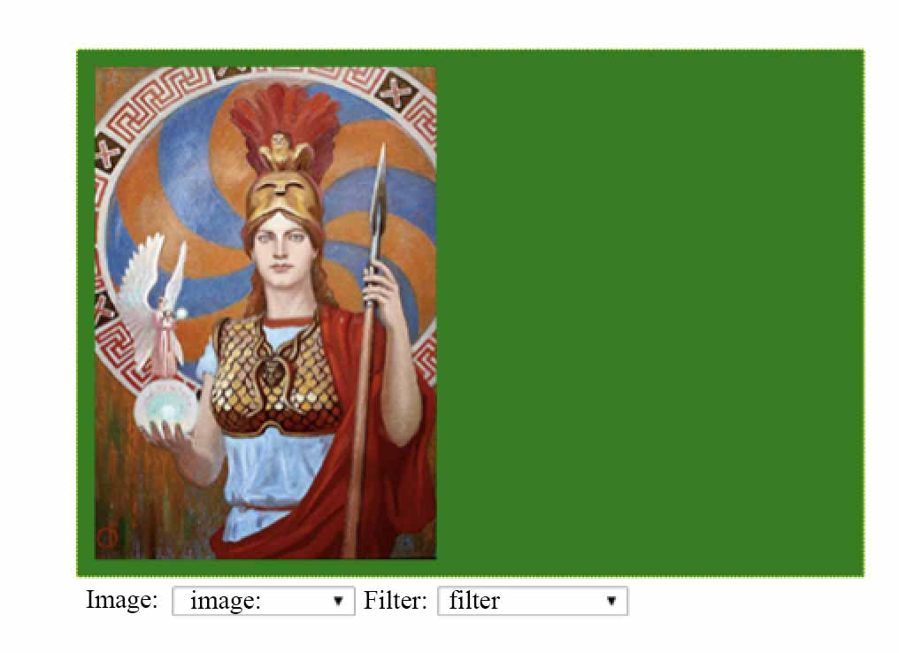

● The size of the canvas should be 460 pixels wide and 320 pixels high.

● Create a drop-down list, with the image options: Athena.jpg, theKiss.jpg, young-pearl.jpg and mona-lisa.jpg. There must be a first option called image.

● Load the images on the canvas depending on the option chosen in the drop-down list.

● The image of athena.jpg is loaded by default.

**Part 2**

● Create a drop-down list, called filter with the options: Darken and Lighten. There must be a first option called filter.

● When choosing a specific image in the dropdown list and applying a filter, the result should appear on the right side of the canvas according to the chosen option.

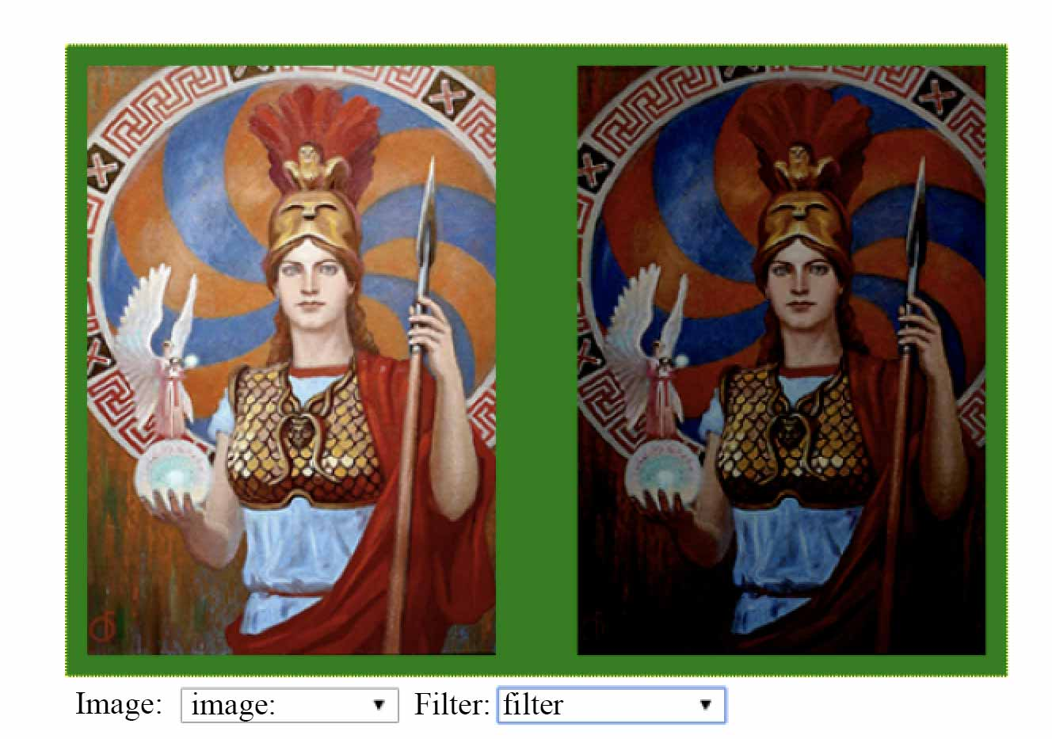

### B4 **Drag** & drop

Be able to rearrange the list to put it in the right order. See video.

## PHP

### C1 Watermark (Easy)

Put a watermark (png file) on the image provided. The watermark should be in the lower right corner.

### C2 Array from textarea

From the information entered in the form's text box, fill an array, each element of which will be an entered text line. Make a var_dump of this array.

Example:

## Instructions for COMPETITORS

You do not have to complete all the tasks. You will be given additional oral information.

For some modules, assets or other resources are provided on the server in the folder with the module number.

**To be provided:** on the server: a zipped folder with your name and surname which contains a sub-folder for each project with the module number in the title.   
The source files (Sass, SCSS, Less, TS) must also be provided as well as the non-minified files in a "src" folder placed in the module folder.

Everything must be ready by the time of the final TOP. No extra time will be given to organise the files after the final top.

## material to be taken by the cOMPETITORS

Personal keyboard or mouse allowed.

## PROHIBITED MATERIAL DURING THE COMPETITION

It is forbidden to use anything that might disturb your work: mobile phones, radios, MP3s.

No digital storage solution

## rating procedure

Except for A3, A4 and C1 which are worth 0 or 2 points, the points are distributed as follows:

1 pt for the HTML structure and visual rendering

1 pt for operation

## SAFETY INSTRUCTIONS

No

## ANNEXES :

Technical document

## Can this document, including annexes, BE sent to competitors before the event?

## NO

## 